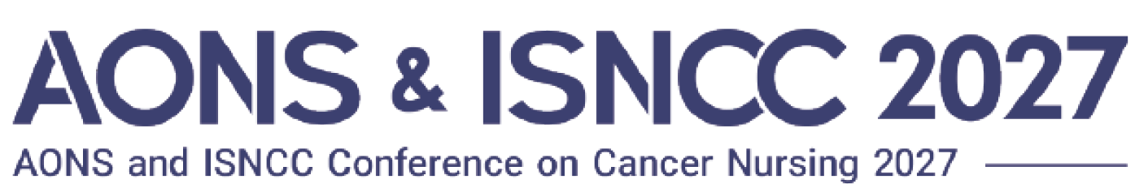
Sponsorship Application Form
  - Your information provided will be published on our official website, venue maps, and delegate handbook etc..
  - All communications, materials, and contracts will be sent to and issued under the contact details provided in this form.
General Information | Company Name | *Company name here will be used for exhibition/ all congress materials. Please enter correctly.
General Information | 貴社名(和文) | (*For Japanese company use )
General Information | Company Website | https:// ***
General Information | Company Address | Country | Enter your country name
General Information | Company Address | Address 1
General Information | Company Address | Address 2
General Information | Contact Person | Name | Enter Here
General Information | Contact Person | Position/Title | Enter Here
General Information | Contact Person | Phone or Mobile | Enter Here
General Information | Contact Person | E-mail | Enter Here
* All prices are in Japanese Yen and exclusive of 10% consumption tax
Sponsorship  /Exhibit Application | Check | - Sponsorship Package | - Please Select |  |  | Sponsorship Fee
Sponsorship  /Exhibit Application | ☐ | Platinum Congress Partner  (1 only available) | Booth  construction |  | -select- | JPY 3,080,000.-
Sponsorship  /Exhibit Application | ☐ | Gold Congress Partner | Booth  construction |  | -select- | JPY 2,200,000.-
Sponsorship  /Exhibit Application | ☐ | Silver Congress Partner | Booth  construction |  | -select- | JPY 1,100,000.-
Sponsorship  /Exhibit Application | ☐ | Rapid- Pitch Presentation | Booth  construction |  | -select- | JPY 550,000.-
Sponsorship  /Exhibit Application |  | - Industry Sponsored Seminar | - Please check Preferable Date
Sponsorship  /Exhibit Application | ☐ | Lunch Seminar Supporter | ☐Aug. 6th ☐Aug. 7th |  |  | JPY 1,650,000.-
Sponsorship  /Exhibit Application | ☐ | Morning Seminar Supporter | ☐Aug. 6th ☐Aug. 7th |  |  | JPY 1,100,000.-
Sponsorship  /Exhibit Application |  | - Catering & others | - Please check Preferable Date
Sponsorship  /Exhibit Application | ☐ | Barista Coffee Lounge Supporter (1 only available) |  |  |  | JPY 1,650,000.-
Sponsorship  /Exhibit Application | ☐ | Coffee Break | ☐Aug. 5th ☐Aug. 6th ☐Aug. 7th |  |  | JPY 330,000.-
Sponsorship  /Exhibit Application | ☐ | Water Station |  |  |  | JPY 330,000.-
Sponsorship  /Exhibit Application | ☐ | Congress Banner |  |  |  | JPY 330,000.-
Sponsorship  /Exhibit Application | ☐ | Delegate Lanyard Partner (1 only available) |  |  |  | JPY 880,000.-
Sponsorship  /Exhibit Application |  | - Exhibition | - Applied Booth Quantity
Sponsorship  /Exhibit Application | ☐ | Shell Scheme Booth ( 2m x 2m) | No. of Booth(s) | -select- |  | JPY 440,000.-
Sponsorship  /Exhibit Application | ☐ | Shell Scheme Booth ( 2m x 2m) | Booth construction | -select- |  | JPY 440,000.-
Sponsorship  /Exhibit Application | ☐ | NFP Booth ( 2m x 2m ) | No. of Booth(s) | -select- |  | JPY 220,000.-
Sponsorship  /Exhibit Application | ☐ | NFP Booth ( 2m x 2m ) | Booth construction | -select- |  | JPY 220,000.-
Note: | If you have any Additional Information, please provide <Here>

■Application Deadline (Primary) : March 31, 2027
■Cancellations: Upon contract establishment, 100% of the total cost will be retained for any cancellation.
By submitting, I confirm I have read and agree to AONS＆ISNCC 2027 Sponsor & Exhibition Prospectus, support the conference objectives, and apply for sponsorship.
Date: Enter Applilcation Date <Here>

